How to Create Systems Map: directions with examples

1. Identify the general/broad topic that you are interested in.
Example: You are interested in the general topic of obesity
2. Brainstorm on the general topic and list all the concepts and themes that are related to the topic on a large piece of paper. Keep the concepts as concise as possible.
Example:
Who?  How many?  Reasons or causes of  Effects of  More fast food  Bigger portions  Large fries  Diabetes  Technology dependent  Stroke  Heart disease  High-blood pressure  Balanced diet  Little sugar | Kids  Adult female  Mothers  Depression  Genetic  More TV viewing  Sedentary life style  Low work productivity  Low self-esteem  Poor emotional health  Physical fitness at work  Balanced diet  Nutritious meals  Less fast food | Obese parents  Unhealthy Diet  Little physical exercise  Soda pop  Dessert  Too much sugar  Commuters  Few pedestrians  How to prevent  Transportation system  Exercise programs  Physical fitness in school  Physical exercise  Walk or pedal to work

3. Using unlined paper, write the main theme in the center of the page.
4. Take the other concepts identified in the brainstorming and connect them to the center concept. You can use other organizational patterns such as branches, arrows or groups. More important ideas should be put nearer to the center and less important ones closer to the edge. Identify the relationship between the concepts.
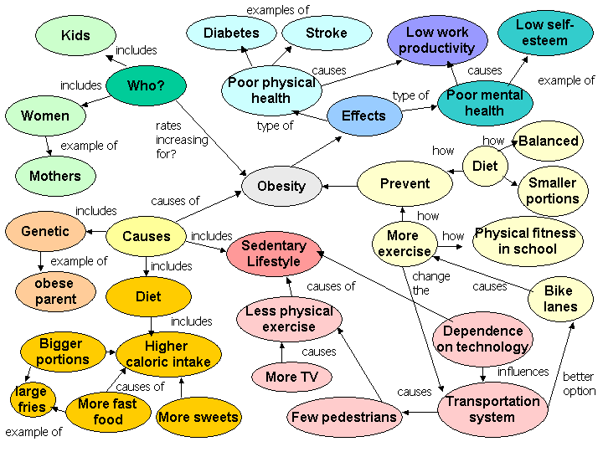
5. After the map has been created, look at the organizational patterns to see if the pieces fit together and make sense and if there is anything missing. After the map has been created, look at the organizational patterns to see if the pieces fit together and make sense and if there is anything missing.

